Asia-Japan-Mirror

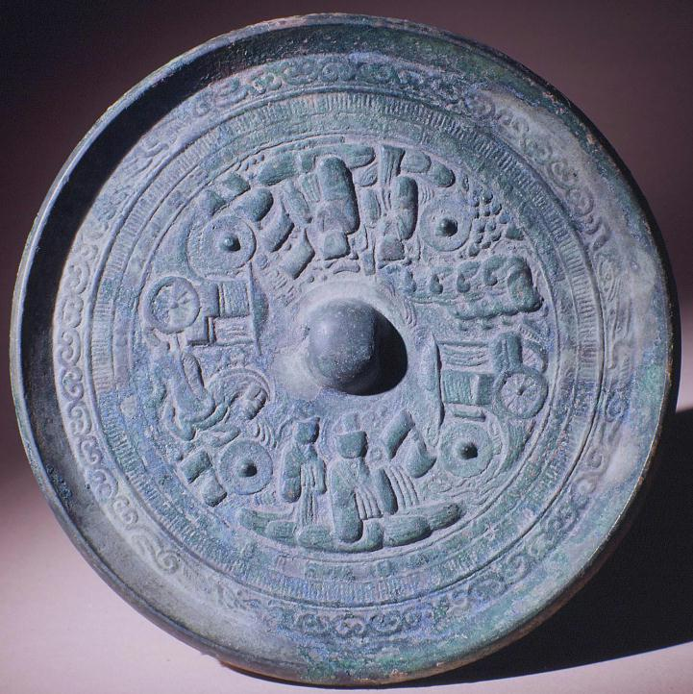

<http://www.ackland.org/art/collection/search/Result.php?accession=91.144>

University of North Carolina at Chapel Hill

## Mirror with Taoist Decoration

ARTIST

Unknown  
Japanese

MEDIUM

Bronze

DATE

3rd-4th century

DIMENSIONS

9/16 x 7 1/4 in. (1.4 x 18.4 cm)

CREDIT

Gift of Charles Millard

BACKGROUND

Japanese mirror made in imitation of Chinese designs. The decoration of this mirror includes two seated figures, probably Taoist divinities, and two carriages, one pulled by a single horse, the other by four horses. Clockwise: one-horse carriage, Xi Wangmu, Queen Mother of the West, four-horse carriage, Dong Wangfu, King Father of the East four miniature mirrors

|  |  |  |
| --- | --- | --- |
|  |  |  |

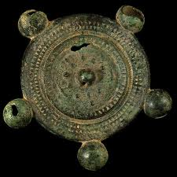

amaterasu: [http://faculty.sxu.edu/~bathgate/gallery/**Japan**/**mirror**](http://faculty.sxu.edu/~bathgate/gallery/Japan/mirror)

600 × 600 - **...** amaterasu: http://faculty.sxu.edu/~bathgate/gallery/**Japan**/**mirror**.jpeg, **...**

forum.nationstates.net

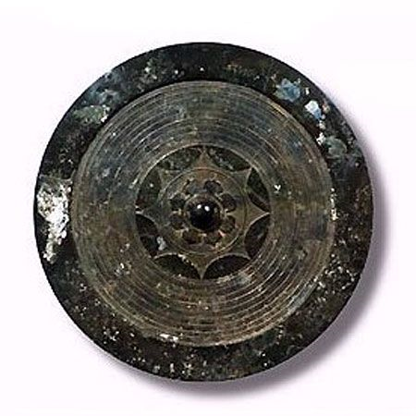

http://files.abovetopsecret.com/files/62a7037c9da8a4e0.jpg